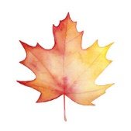**LEBANON JUNCTION’S**

**ANNUAL**

**MAIN STREET FESTIVAL**

***Held on Main Street in Downtown Lebanon Junction***

**FRIDAY, OCTOBER 4**

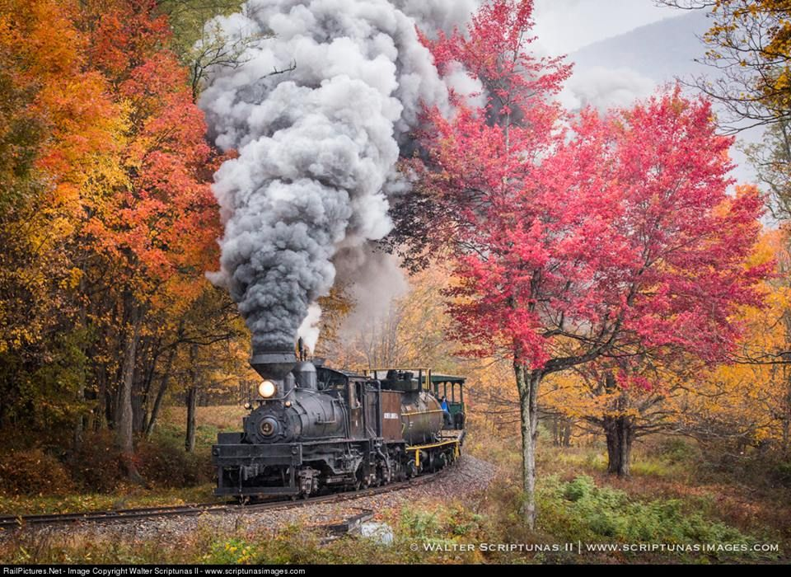**SATURDAY, OCTOBER 5**

**VENDORS FOR SHOPPING**

**MINIATURE TRAIN RIDES FOR KIDS**

**FRIDAY AND SATURDAY**

**FOOD BOOTHS**

**FRIDAY & SATURDAY**

**PANCAKE BREAKFAST AT FIREHOUSE ON SATURDAY MORNING**

**AXE**

**THROWING!**

**LIVE MUSIC**

**FRIDAY & SATURDAY EVENING**

**CAKE WHEEL**

**AND RAFFLES**

**INFLATABLES ON**

**FRIDAY AND SATURDAY!**

**PET COSTUME**

**CONTEST**

**PARADE**

**SATURDAY MORNING STARTING AT 10:00 AM**