**Pet Costume Contest**

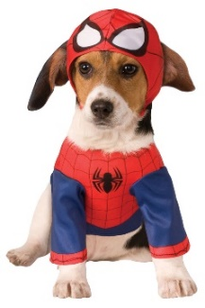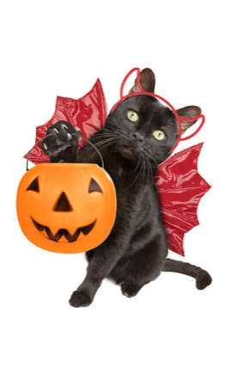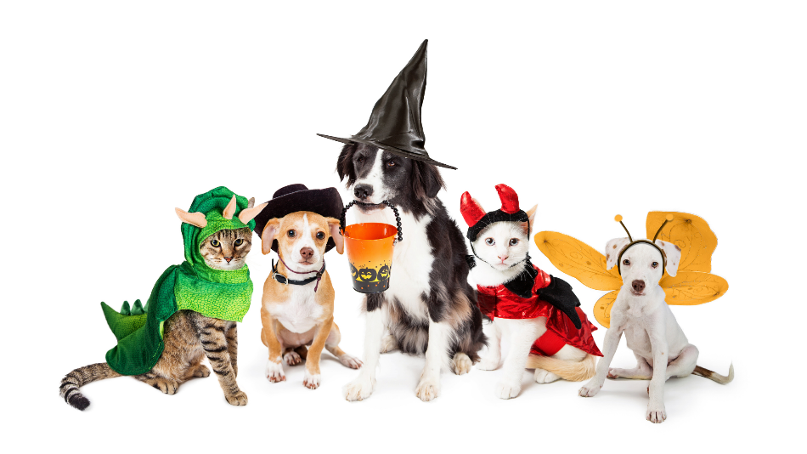

**October 5, 2024**

**3:00 PM**

**LJ Main Street Festival**

***(Contest will be held by the caboose in downtown LJ)***

**$5 entry fee**

**Prizes will be awarded**

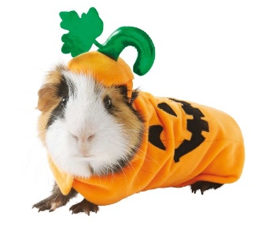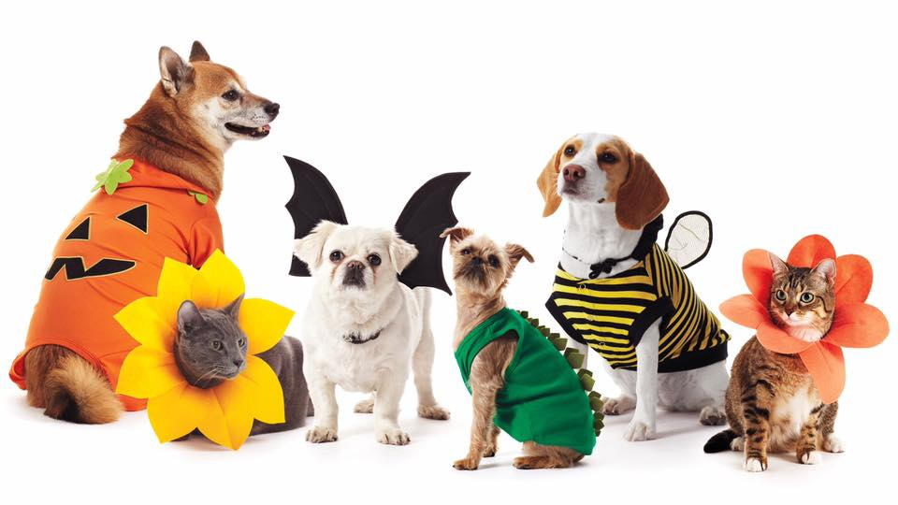

**Sponsored by:**

**Barktown Rescue**