**Pet Costume Contest**

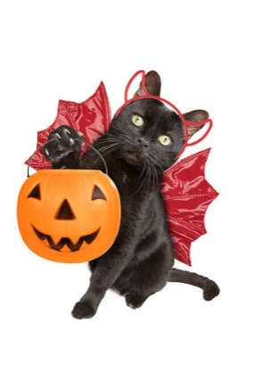**Registration Form**

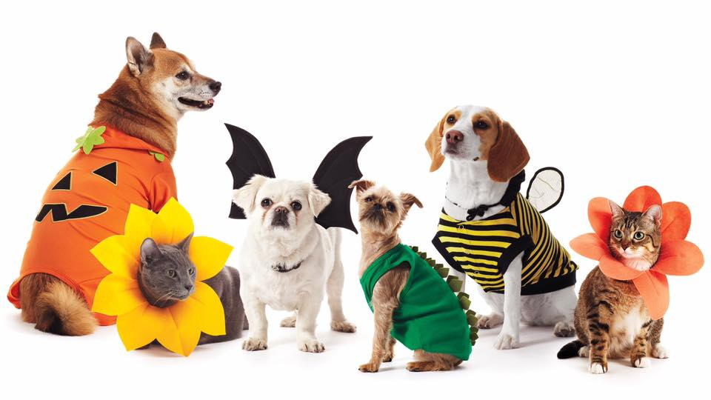

**Contest will be held at the LJ Main Street Festival on October 5, 2024 at 3:00 PM**

Owners Name:

Phone Number:

Pet’s Name:

Breed:

Age of Pet:

Interesting Fact(s):

**Entrance Fee:** $5  Paid

(all entrance money will be donated to Barktown Rescue)

Registration forms can be turned in early at LJ City Hall or on the day of the contest at the Barktown Rescue booth.

**Please read and sign below:**

* Please ensure that all animals are properly secured
* The pet must be with the owner at all times
* All pets must be registered on this registration form
* All contestants must be present when your number is called or will be forfeited

I, , read and understand the rules set forth on this registration form and will not hold the City of Lebanon Junction or Barktown Rescue responsible or liable for any personal injury or property damage that may arise from this contest.

**Participant Signature Date**