With Thanks to our Many, Many Sponsors:  Bullitt County Tourism  First Harrison Bank  Bluegrass Engineering (Matt Curtis)  Mac Manufacturing  Bullitt County Supermarket  VFW #5710 Shepherdsville  VFW Auxiliary Post 5710  S.O. Contracting  Argenbright Dirt Works  Scotty’s Paving  American Legion #157  Above All Mechanical  Trowbridge Funeral Home  Vittitoe Services  JHK Mart  BSM Battery  Tammy Baker, County Attorney  Jerry Summers, Bullitt Co. Judge Executive  Dangerfield Construction  Bullitt County Rod & Gun Club  Bullitt Country Rod & Gun Club Ladies Auxiliary  Mamee’s Tanning & Laundry  Ewing’s Body Shop  Quentin Johnson Farms  Huff’s Used Cars  Insurance Connections  105 South Liquors  Lebanon Junction Order of the Eastern Star #72  McDonald’s  LJ Depot Diner  McNeil Lodge #586  Daddio’s Pizza  Sweet Country Creations  Little Rick’s Bar & Grill  Bennett’s Gas – Donation of Propane for Fish Fry  City of Hillview – Donation of Train |  | Lebanon Junction  Main Street Festival  2024  October 4th & 5th  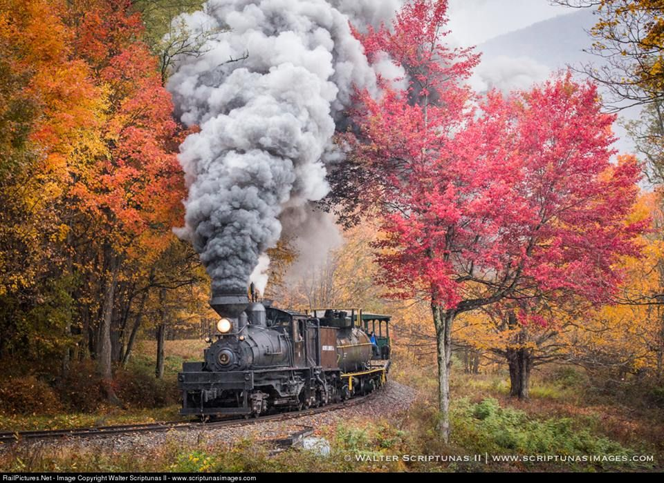  “Old Fashion Festival”  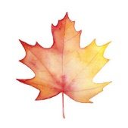  Sponsored by the LJ Festival Committee

FRIDAY – October 4th:  Downtown Lebanon Junction (Main Street):  - Booths & Concessions start at 5:00 PM  - “Casey & Romy” Band (6 PM-9 PM)  - Live Chainsaw Carving by Derek Richardson’s Chainsaw Art  Located at city property at the end of Railroad Avenue:  - Bounce Around E-town Inflatables:  Armband $10 – good from 5 PM-9 PM  7 Different Inflatables to Choose From!  Entertainment for all ages!  - Miniature Train Rides – Free (starts at 5 PM)  Community Center:  - LJ Railroad City Lions Club Art Show  $1 Entry Fee  Friday: 6 PM-9 PM & Saturday: 12 PM-6 PM  Drop off items on 10/5 between 3 PM-6 PM  Pick up items 10/7 between 6 PM-7 PM  Parade Information:  Please contact LJ City Hall 502-833-4311  Entry: Minimum of $5 Donation Appreciated (Politicians $35)  Trophies will be awarded to winner in each category  Line-up begins at 9 AM at Pilot  There will be a “no siren” zone from Brook Street through downtown for children/adults with autism, and other medical issues to be able to enjoy the parade.  Entry Forms:  Can be obtained at the City Hall,  Printed from the town’s website: www.lebanonjunctionky.com ,  or at Pilot the morning of Parade |  | SATURDAY – October 5th:  Downtown Lebanon Junction (Main Street):  - Firehouse Annual Pancake Breakfast 7-10 AM - $8.00  - Parade starts at Pilot at 10:30 AM  - Booths & Concessions start at 12:00 PM  - Live Chainsaw Carving by Derek Richardson’s Chainsaw Art  - Hippy Chic DJ/Karaoke (2:00 PM-5:00 PM)  - Pet Costume Contest (sponsored by Barktown Rescue)  - Contest starts at 3:00 PM - $5 entry  - Contest will be held by the caboose  - Cake Wheel (ran by Dennie Memorial Methodist Church)  Starts at 12 PM and will last until cakes are gone.  (located at Mamee’s)  - “Exit 105” Band (7 PM-10 PM)  - Axe Throwing  Located at city property at the end of Railroad Avenue:  - Bounce Around E-town Inflatables:  Armband $15 – good from 12 PM-9 PM  5 Different Inflatables to Choose From!  Entertainment for all ages!  - Monster Trucks (shown in parade) will be available for kids to check out  - Miniature Train Rides – Free (starts at 12 PM)

